EXP NO 4:
CREATE A SIMPLE CLOUD SOFTWARE APPLICATION FOR CAR BOOKING RESERVATION SYSTEM USING ANY CLOUD SERVICE PROVIDER TO DEMONSTRATE SAAS.
DATE:
AIM:
To Create a simple cloud software application for Car Booking Reservation System using any Cloud Service Provider to demonstrate SaaS. PROCEDURE: step1: Go to zoho.com. step 2: Log into the zoho.com. step 3: Select one application step. step4: Enter application name as Car Booking Reservation System. step 5: Created new application as Car Booking Reservation System.
step 6: Select one form step 7: The software has been created.
FROM DESIGN:
1.REGISTRATION
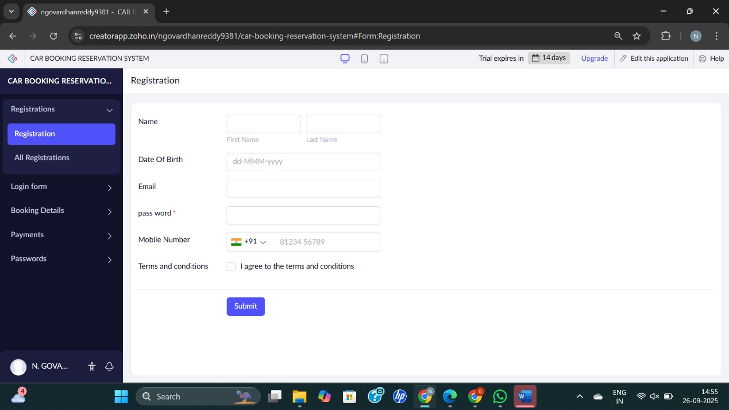
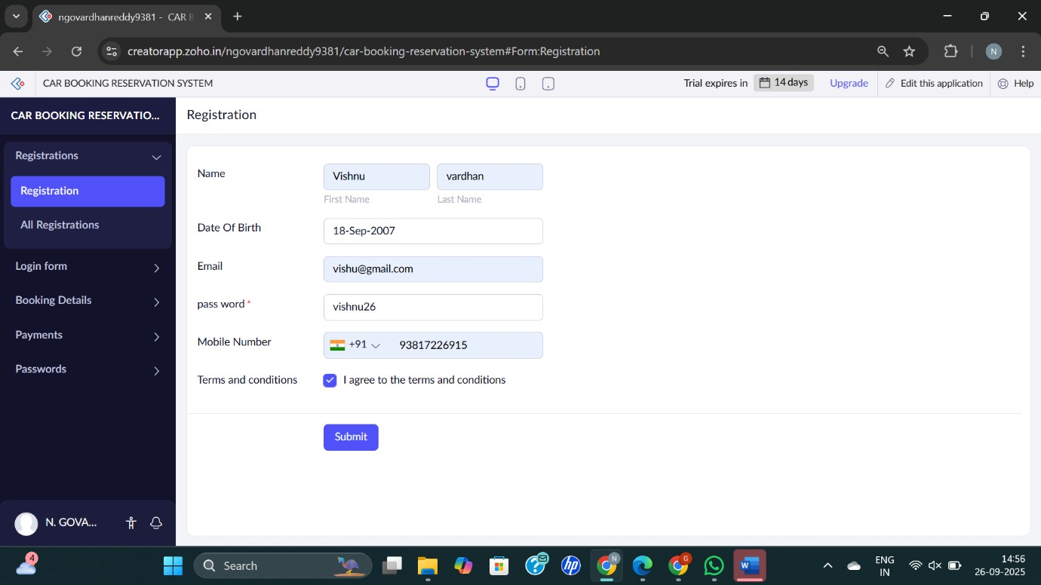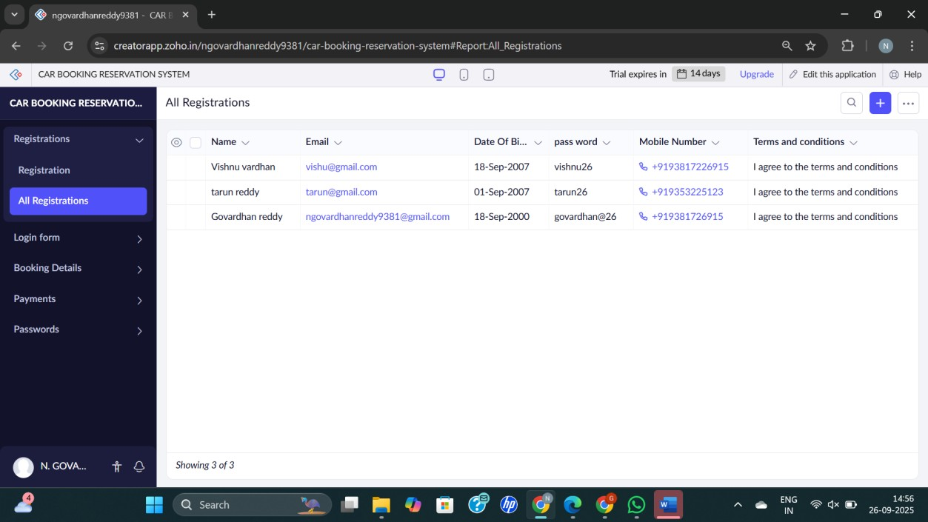

- login form
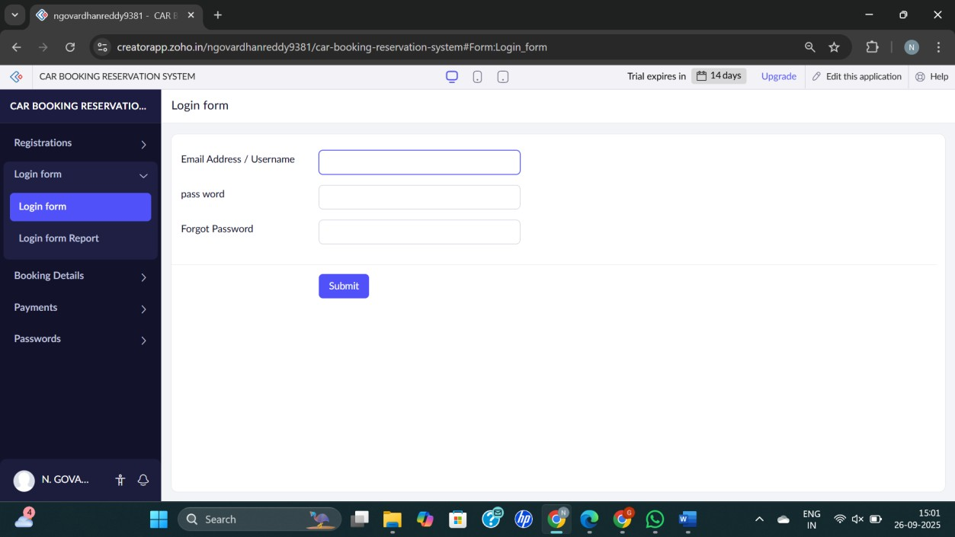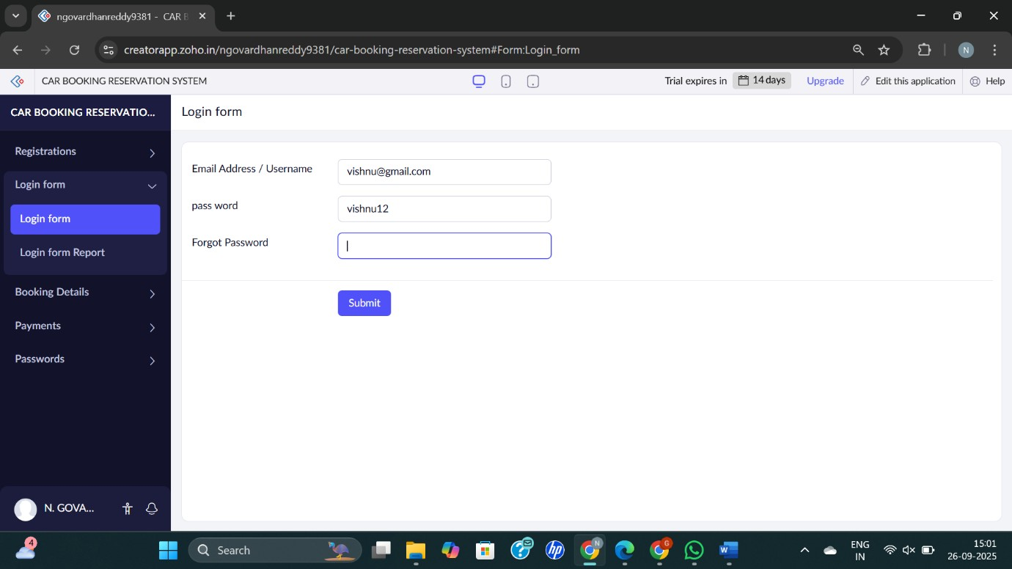
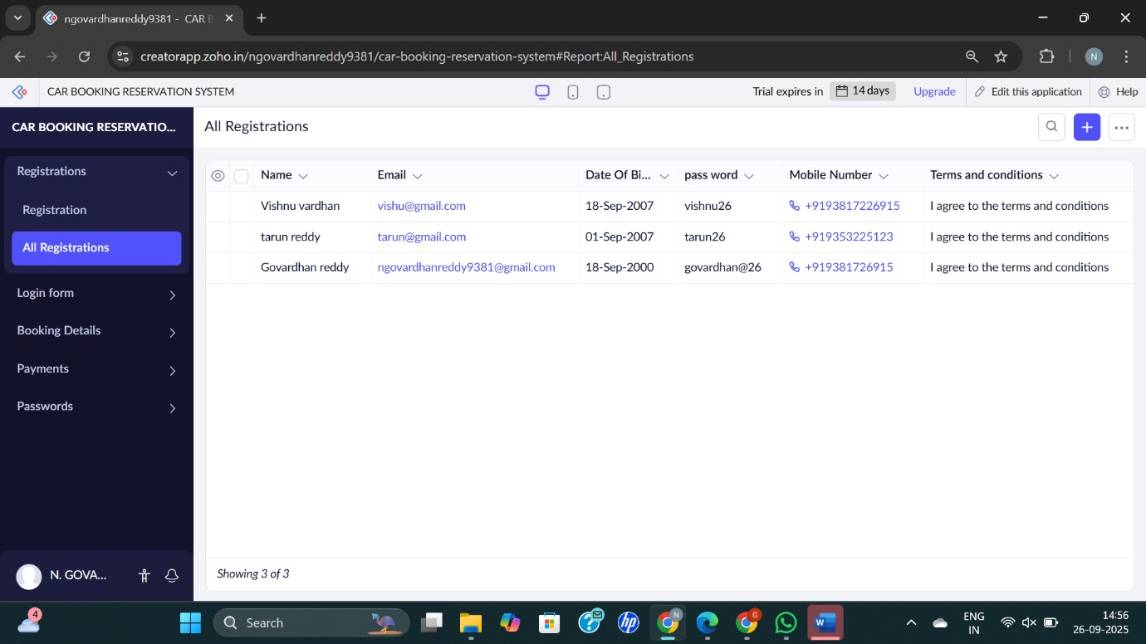

- PAYMENT
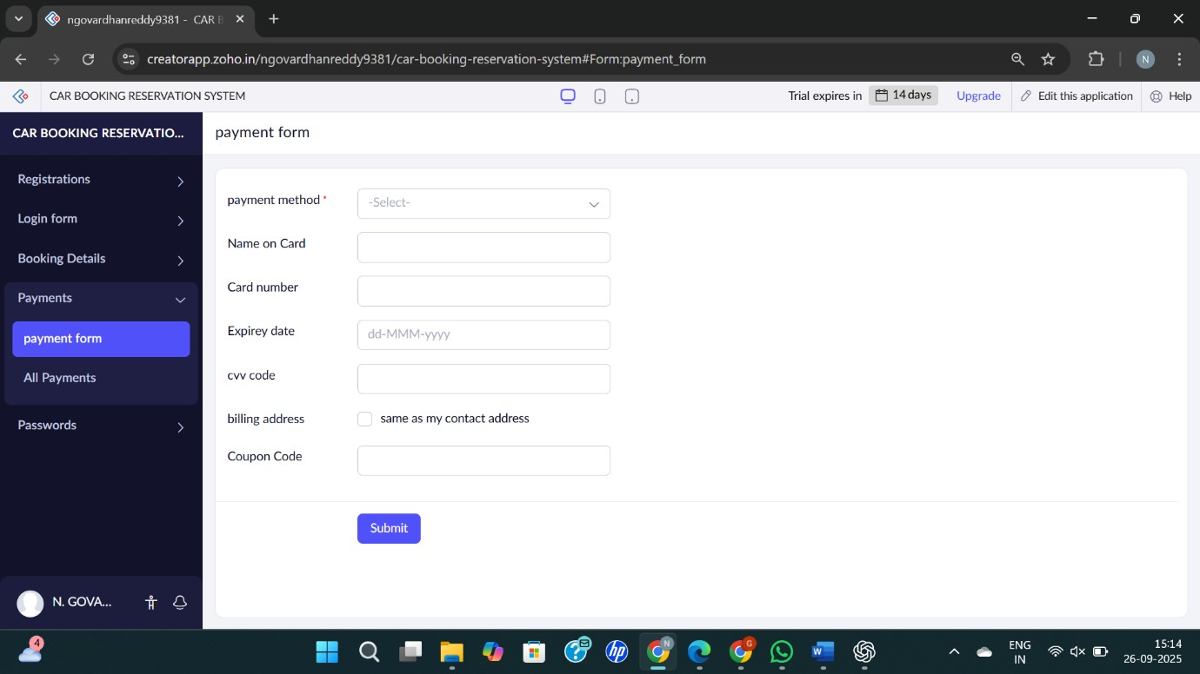
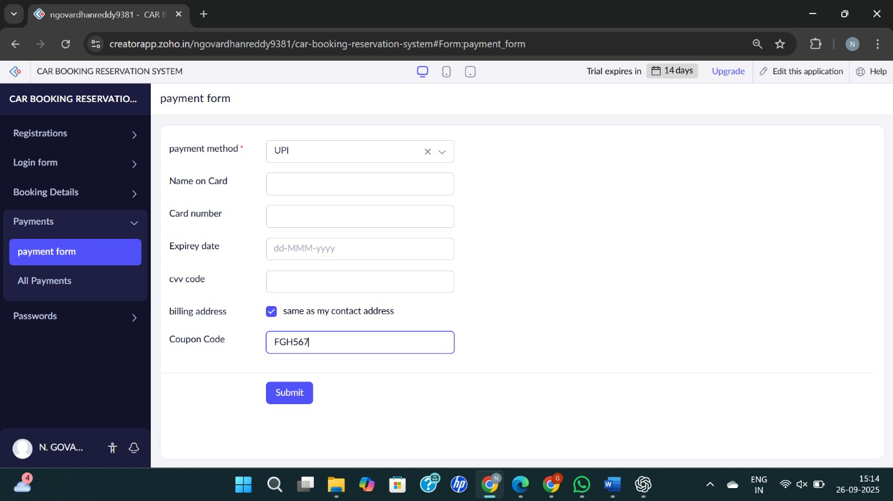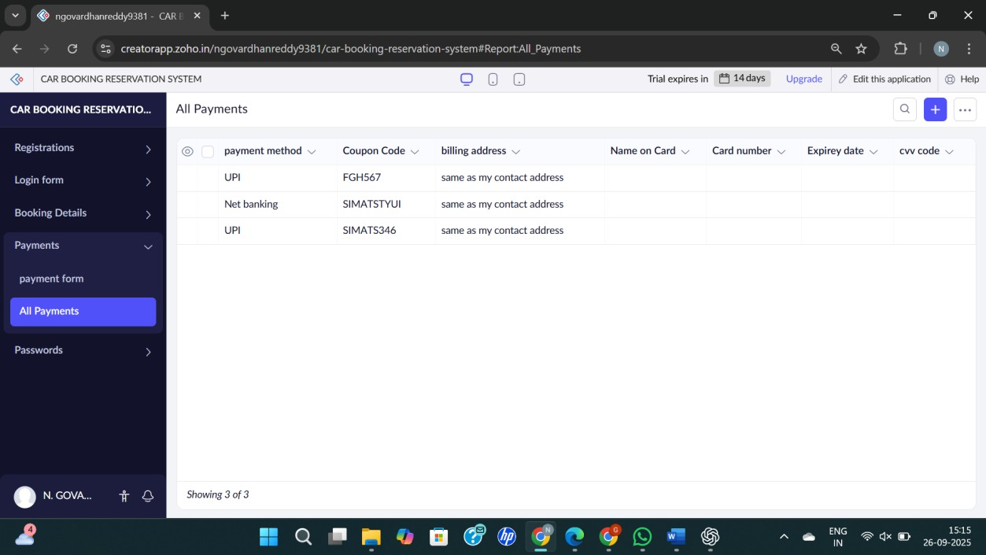

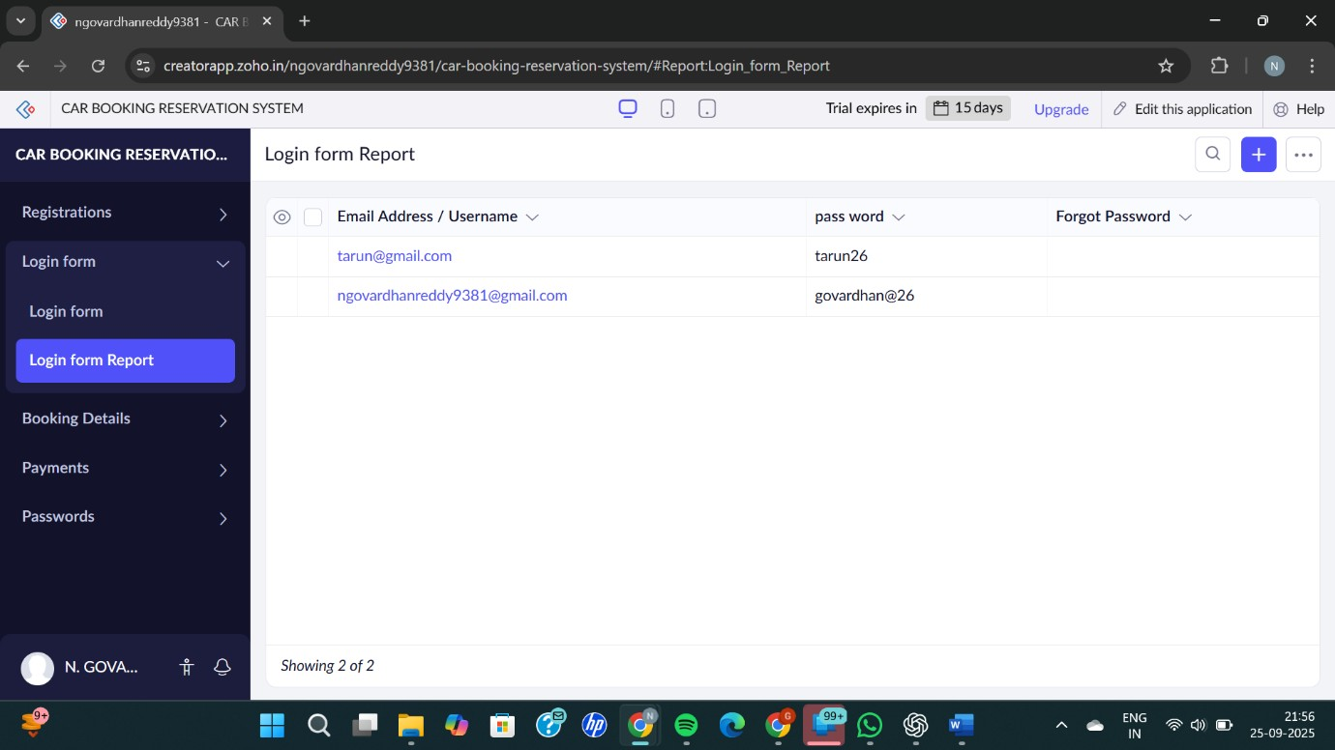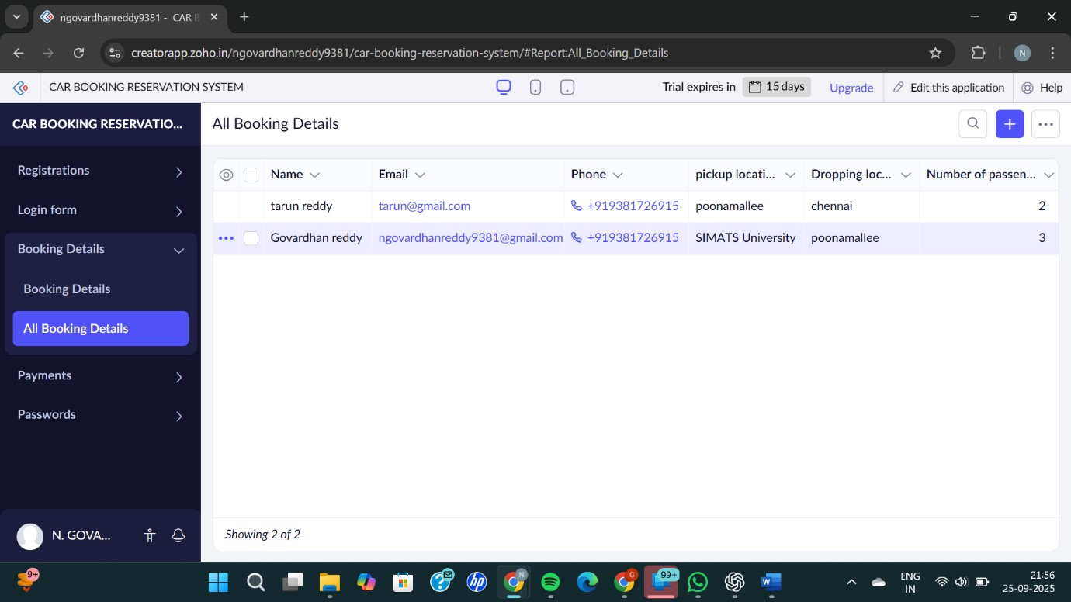

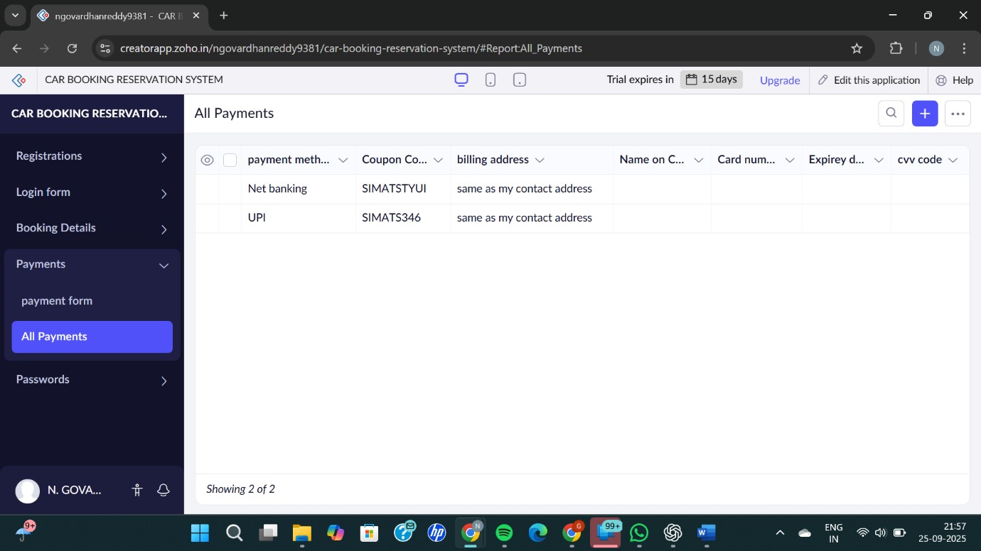
RESULT:
Successfully created a simple cloud software application for car booking reservation system using any cloud service provider to demonstrate SaaS

